INTERPOLATION
Q. WRITE A PROGRAM IN PYTHON TO DEMONSTRATE NEWTON FORWARD INTERPOLATION.
AIM: TO WRITE A PROGRAM IN PYTHON TO DEMONSTRATE NEWTON FORWARD INTERPOLATION.

PROGRAM:
def forward_difference_table(x, y):
n = len(y)
diff_table = [y.copy()] # First row is just y values

# Generate the forward difference table
for i in range(1, n):
row = []
for j in range(n - i):
# Calculate the i-th difference: diff(j) = diff(j+1) - diff(j)
value = diff_table[i-1][j+1] - diff_table[i-1][j]
row.append(value)
diff_table.append(row)

return diff_table

def display_table(x, diff_table):
n = len(x)
print("\nForward Difference Table:")
header = "i\t x\t\t y" + "\t\t Δy" * (n - 1)
print(header)
print("-" * len(header) * 2) # For visual separation

for i in range(n):

row = [str(i), f"{x[i]:.2f}", f"{diff_table[0][i]:.2f}"]
# Add the differences
for j in range(1, n - i):
row.append(f"{diff_table[j][i]:.2f}")
print("\t".join(row))

def main():
n = int(input("Enter the number of data points: ")
x = []
y = []
print("Enter x values (equally spaced):")
for i in range(n):
x.append(float(input(f"x[{i}] = ")))
print("Enter corresponding y values:")
for i in range(n):
y.append(float(input(f"y[{i}] = "))
# Check equal spacing
h_values = []
for i in range(n - 1):
h_values.append(x[i+1] - x[i])
# Check if all h values are approximately equal
if not all(abs(h_values[i] - h_values[0]) < 1e-5 for i in range(n - 1)):
print("\nError: X values are not equally spaced.")
return
diff_table = forward_difference_table(x, y)
display_table(x, diff_table
if _name_ == "_main_":
main()

OUTPUT:
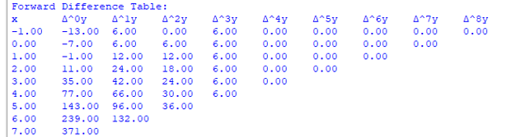

CONCLUSION:
THE ABOVE PROGRAM HAS BEEN EXECUTED SUCCESSFULLY

